8th Grade Social Studies
Standard | 3.0 Items
(1) History. The student understands traditional historical points of reference in U.S. history through 1877. The student is expected to:
(A) identify the major eras and events in U.S. history through 1877, including colonization, revolution, drafting of the Declaration of Independence, creation and ratification of the Constitution, religious revivals such as the Second Great Awakening, early republic, the Age of Jackson, westward expansion, reform movements, sectionalism, Civil War, and Reconstruction, and describe their causes and effects;

 | 2.0 Items
CP1

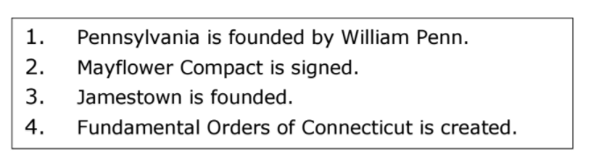

All of the events listed above characterize which era?

A Renaissance
B Revolution
C Great Awakening
D Colonization

Ans: D
29B

Standard | 3.0 Items
(2) History. The student understands the causes of exploration and colonization eras. The student is expected to:  (A) identify reasons for European exploration and colonization of North America | CP1  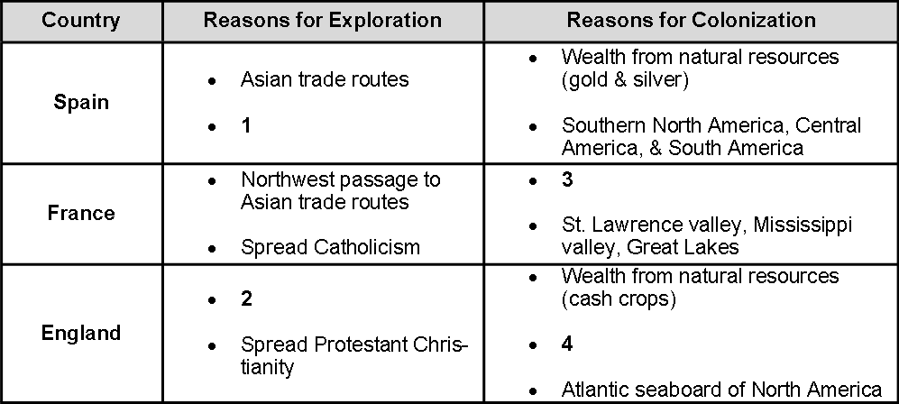  Which reason is correctly matched with the number in the chart?  - 1 – Spread Protestant Christianity  - 2 – A Northwest Passage to Asian trade routes  - 3 - Wealth from natural resources (gold & silver)  - 4 – Escaping economic depression  Ans: B  29B
 | 2.0 Items

Standard | 3.0 Items
(2) History. The student understands the causes of exploration and colonization eras. The student is expected to:
(B) compare political, economic, religious, and social reasons for the establishment of the 13 English colonies

 | 2.0 Items
CP1

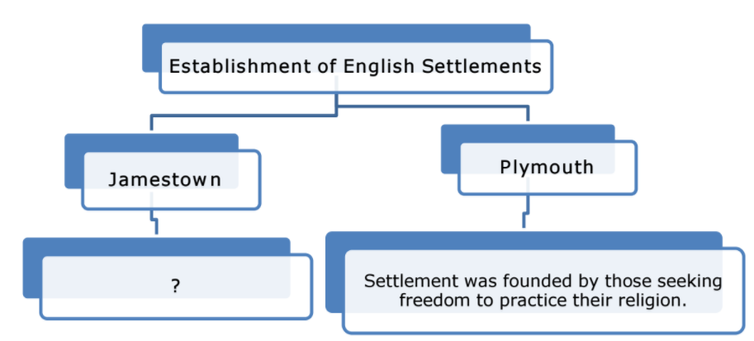

What statement correctly completes the diagram above?

F Settlement was founded as a military outpost to protect New England.

G Settlement was founded for economic reasons to make money.

H Settlement was founded to be a model religious community.

J Settlement was founded to resettle prisoners and debtors.

Ans: G
29B

Standard | 3.0 Items
(3) History. The student understands the foundations of representative government in the United States. The student is expected to:
(A) explain the reasons for the growth of representative government and institutions during the colonial period;

 | 2.0 Items
CP1
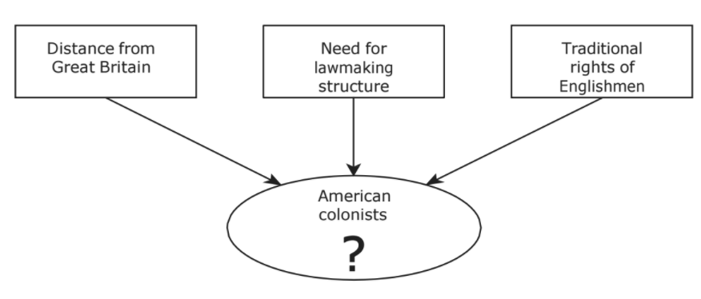

Which of the following best replaces the question mark in the diagram above?

A Created a general council to manage the colonies.

B Experienced strict control by Parliament.

C Established their own representative institutions.

D Appointed governors who reported to the King.

Ans:C
29B

Standard | 3.0 Items
(3) History. The student understands the foundations of representative government in the United States. The student is expected to:
(B) analyze the importance of the Mayflower Compact, the Fundamental Orders of Connecticut, and the Virginia House of Burgesses to the growth of representative government

 | 2.0 Items
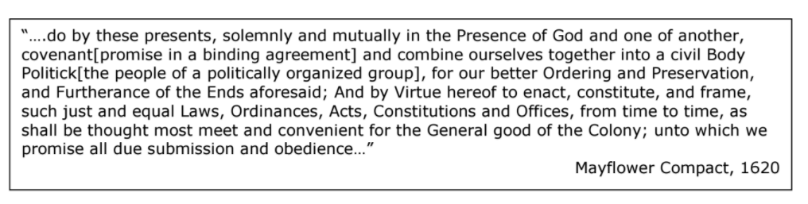

Which statement best explains the significance of the document above?

F It limited the power of future governments.

G It weakened the influence of religion in government.

H It established a form of self-government based on a social contract.

J It guaranteed liberties for colonists through local government.

CP1
The Virginia House of Burgesses and the Mayflower Compact had a similar effect in that both

- Reinforced English policies of the colonies
- Gave settlers the power to establish colonies
- Contributed to the development of representative democracy
- Granted absolute authority to colonial governors

Ans: C

The Mayflower Compact is important to the idea of a democratic society because it represents

- An effort by colonists to resist the King
- A clear step towards self-government
- An early attempt to establish universal suffrage
- An attempt by colonists to establish religious freedom

Standard | 3.0 Items
(10) Geography. The student understands the location and characteristics of places and regions of the United States, past and present. The student is expected to:
(B) compare places and regions of the United States in terms of physical and human characteristics

 | 2.0 Items
CP1
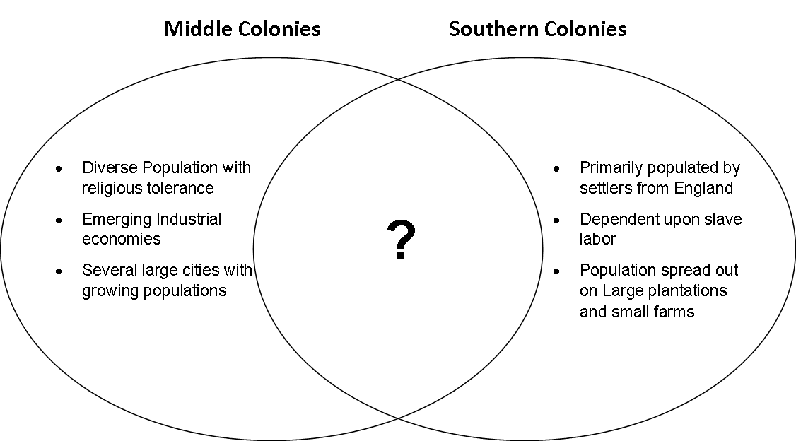
Which of the following best completes the Venn Diagram above?

- Economy solely based on shipbuilding and farming
- Climate that allows a year round growing season
- Land characterized by thin, rocky soil
- Economy largely based on the production of cash crops

Ans: D
29B

Standard | 3.0 Items
(10) Geography. The student understands the location and characteristics of places and regions of the United States, past and present. The student is expected to:
(C) analyze the effects of physical and human geographic factors on major historical and contemporary events in the United States.

 | 2.0 Items
CP1
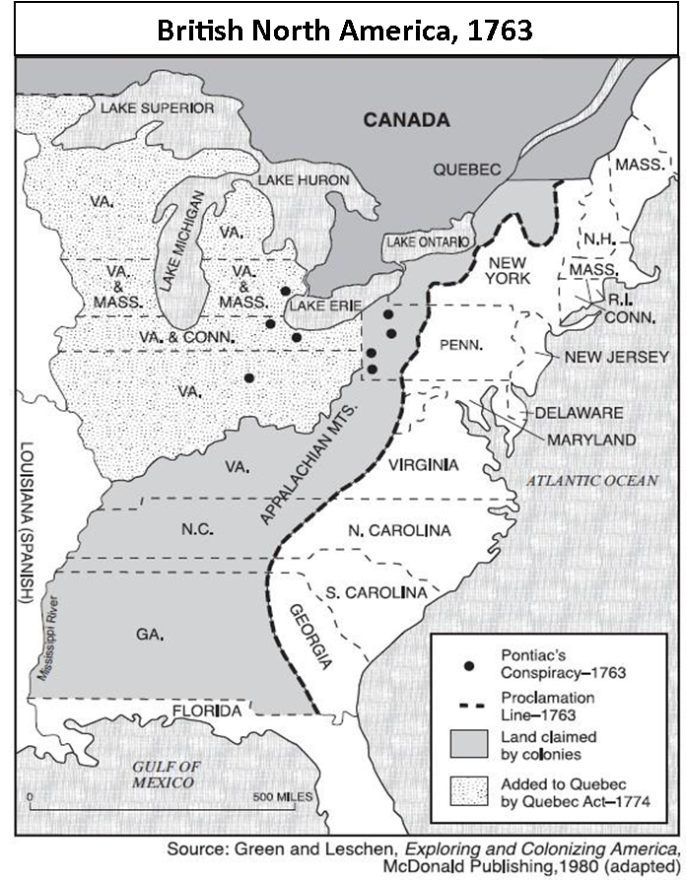

What was the reason that King George III issued a proclamation that divided British North America as shown on the map above?

- The King planned to sell the western lands to the Dutch to pay off debts from the French and Indian War.

- The King wanted to prevent conflict between Native Americans west of the Appalachian Mountains and the American colonists.

- The King had promised the western lands to the Prussian soldiers who had fought for the British in the French and Indian War.

- The King banned the American colonists from settling west of the proclamation as punishment for instigating the war with France.

Ans: B
29C

Standard | 3.0 Items
(11) Geography. The student understands the physical characteristics of North America and how humans adapted to and modified the environment through the mid-19th century. The student is expected to:
(A) analyze how physical characteristics of the environment influenced population distribution, settlement patterns, and economic activities in the United States during the 17th, 18th, and 19th centuries

2.0 Items

CP1
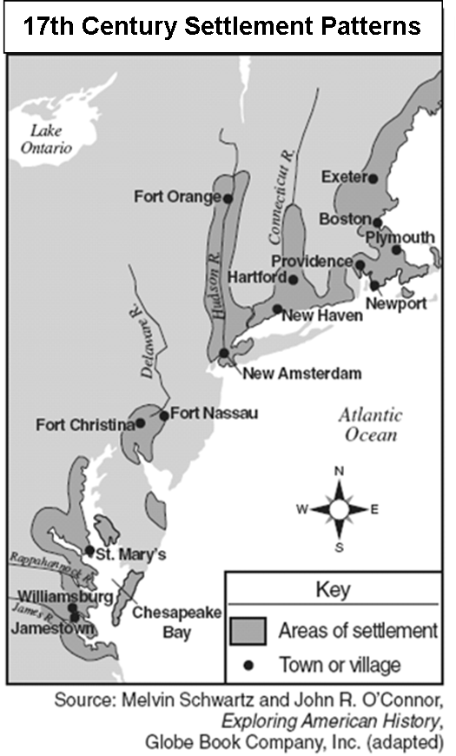

Based on the location of towns and cities on the map which of the following best explains how physical characteristics of the environment influenced colonial settlement?

A Colonists located their towns mostly on inland rivers to avoid contact with Native American Indians.

B The location of early settlements was limited by the mountainous geography.

C Early colonists located settlements in order to have access to transportation and supplies.

D American Indians helped colonists move into their already established villages.

Ans: C
29C

Standard | 3.0 Items
(12) Economics. The student understands why various sections of the United States developed different patterns of economic activity. The student is expected to:
(A) identify economic differences among different regions of the United States

 | 2.0 Items

Standard | 3.0 Items
(12) Economics. The student understands why various sections of the United States developed different patterns of economic activity. The student is expected to:
(B) explain reasons for the development of the plantation system, the transatlantic slave trade, and the spread of slavery

2.0 Items
CP1
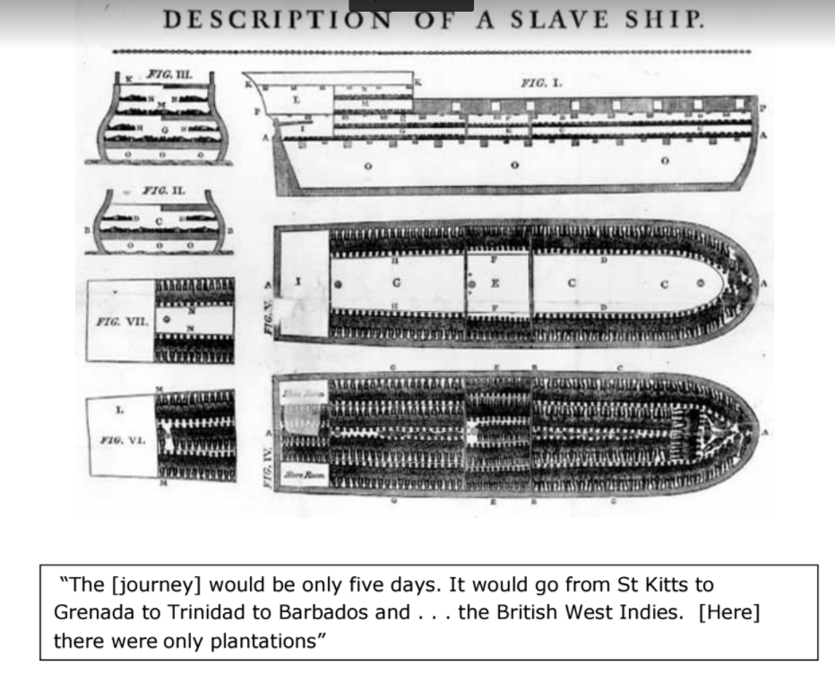

The picture and quotation provide information related to -

A life on the middle passage.

B farming in the Southern Colonies.

C the effects of the Townshend Acts.

D experiences of New England sailors.

Ans:A
29B

Standard | 3.0 Items
(12) Economics. The student understands why various sections of the United States developed different patterns of economic activity. The student is expected to:
(D) analyze the causes and effects of economic differences among different regions of the United States at selected times in U.S. history.

 | 2.0 Items
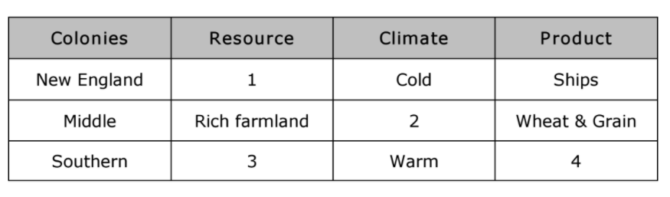

Which characteristic is correctly matched with a number in the table?

A 1: Tobacco and Indigo

B 2: Tropical

C 3: Iron ore

D 4: Cash crops

CP1

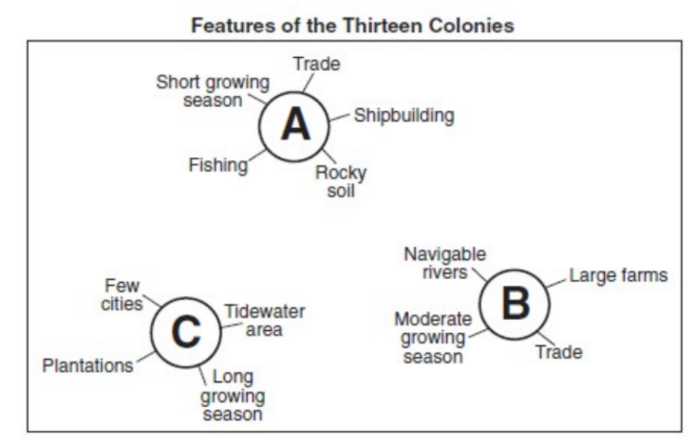
Comparing the characteristics of A and B in the graphics, what conclusion can be drawn about their economies?

A Because of the growing season, they both depended on slave labor to drive their economy.

B Because of their access to natural harbors, trade played a major role in their economies.

C Because of the rich, fertile soil, subsistence farming dominated their economies.

D Because of the lack of navigable rivers, few cities developed inland.

Ans:B
29B

Standard | 3.0 Items
(20) Citizenship. The student understands the importance of voluntary individual participation in the democratic process. The student is expected to:
(A) explain the role of significant individuals such as Thomas Hooker, Charles de Montesquieu, John Locke, William Blackstone, and William Penn in the development of self-government in colonial America

 | 2.0 Items
CP1
Established colony for Quakers in North America to safely practice religious beliefs

Established treaties with Native Americans and promoted fair treatment and payment for Native lands

Wrote Constitution for his colony that created a General Assembly to provide representation for colonists

Who is the individual that is described above?
- Thomas Hooker
- Roger Williams
- William Penn
- John Rolfe

Ans - B
29B

Standard | 3.0 Items
(23) Culture. The student understands the relationships between and among people from various groups, including racial, ethnic, and religious groups, during the 17th, 18th, and 19th centuries. The student is expected to:
(A) identify selected racial, ethnic, and religious groups that settled in the United States and explain their reasons for immigration

 | 2.0 Items
CP1

Quakers immigrated to the Pennsylvania colony primarily to

- Profit from natural resources
- Avoid crop failures and famine
- Produce cash crops to pay off debts
- Escape persecution

Ans: D

Standard | 3.0 Items
(25) Culture. The student understands the impact of religion on the American way of life. The student is expected to:
(A) trace the development of religious freedom in the United States

 | 2.0 Items

Standard | 3.0 Items
(10) Geography. The student understands the location and characteristics of places and regions of the United States, past and present. The student is expected to:

(A) locate places and regions of importance in the United States during the 17th, 18th, and 19th centuries;

 | 2.0 Items
CP1

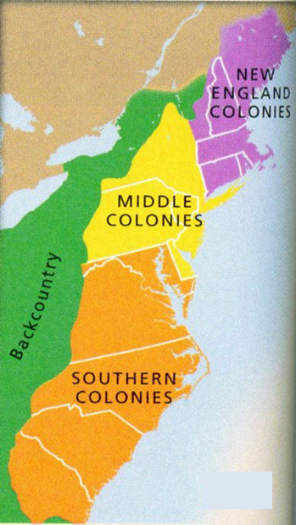

Which of the following correctly matches the colonial region that developed due to a favorable location and naturally deep harbors with one of the major cities of that region?

- New England; New York City
- Middle Colonies; Philadelphia
- Southern Colonies; Hartford
- New England; Baltimore

Ans: B
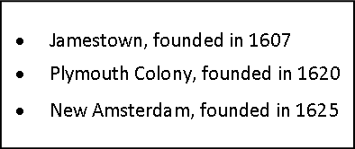
These early colonial settlements were similar in that they were all located

- At the base of a mountain range
- Near the coastline
- In an arid climate
- On offshore islands

The original settlements in the original 13 British colonies were all located

- On the Great Plains
- Along the Gulf Coast
- East of the Appalachian Mountains
- West of the Mississippi River

Standard | 3.0 Items
(23) Culture. The student understands the relationships between and among people from various groups, including racial, ethnic, and religious groups, during the 17th, 18th, and 19th centuries. The student is expected to:

(E) identify the political, social, and economic contributions of women to American society.

 | 2.0 Items
CP1

Which of the following political and social impacts resulted from Anne Hutchinson being banished from the Massachusetts Bay colony?

- The creation of Connecticut and the expansion of women's voting rights
- The founding of Rhode Island and the expansion of religious freedom
- The organization of Virginia’s House of Burgesses and the expansion of representative government
- The establishment of the Maryland Toleration Act welcomes settlement by European Catholics

Ans: B

Standard | 3.0 Items
(25) Culture. The student understands the impact of religion on the American way of life. The student is expected to:

(A) trace the development of
Religious freedom in the United States

 | 2.0 Items
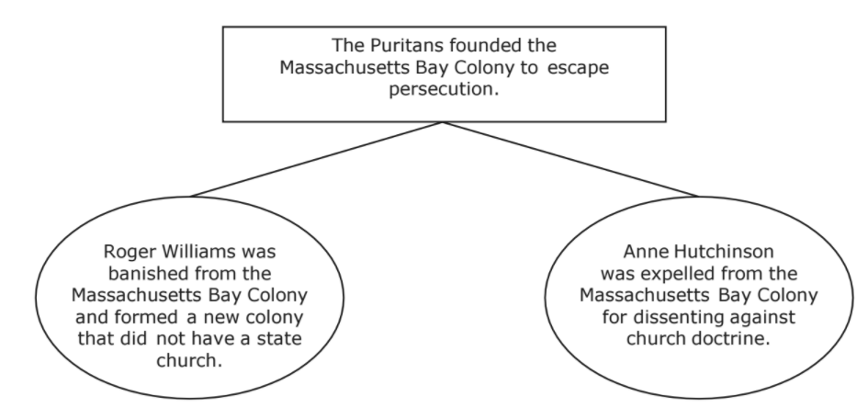

This diagram describes events in colonial America that are related to —

A the eventual adoption of the U.S. Constitution.

B the formation of a government controlled by religious officials.

C the creation of a national system of checks and balances.

D the establishment of the principle of religious freedom.

CP1
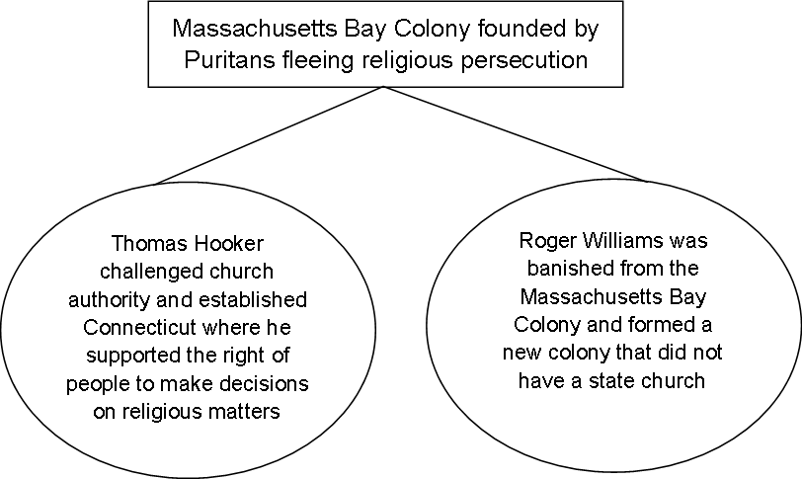

This diagram describes events in colonial America that are related to —

A the eventual adoption of the U.S. Constitution.

B the formation of a government controlled by religious officials.

C the creation of a national system of checks and balances.

D the establishment of the principle of religious freedom.

Ans:D
29B

Standard | 3.0 Items
(1) History. The student understands traditional historical points of reference in U.S. history through 1877. The student is expected to:

(C) explain the significance of the following dates: 1607, founding of Jamestown; 1620,

 | 2.0 Items

